**Roundtable**

September 9, 2021

1. **Join Scouting /Rus P**
   * *Join Scouting/Resources*
     + National Membership Kickoff [Webinar](https://vimeo.com/580145440)
     + Tell the benefits – leadership, normal friend activities, scholarship
     + Lead with Volunteers – have the Committee Members/parents pitch Scouting
     + Get the commitment – have on-line registration and payment
     + Cub Scouts – Videos at [brand center](https://scouting.webdamdb.com/bp/); sample Scout Life Magazine
     + [Recruitment Kit](https://blog.scoutingmagazine.org/2021/07/29/use-this-new-recruitment-kit-to-help-spread-the-word-about-scouting/?utm_source=scoutingwire&utm_campaign=swvolunteer842021&utm_medium=email&utm_content=) – online resources available
     + Update your PIN at BeAScout.org
     + Council Resources (allow two weeks) – [jose.calil@scouting.org](mailto:jose.calil@scouting.org)
     + Flyers, yard signs
     + Geofencing for Facebook
     + Marketing Materials (email at 5pm today)
2. **Council Update /Hector U**
   * Last year, the recharter process was very flexible due to COVID
   * This year, we would like Units to submit by November 1
   * There will be a new Charter Renewal system online by September 15. Training will be provided. To prepare:
     + August 1 – Oct 14 – Membership inventory, add members, get annual agreement signed
     + Oct 15 – Oct 31 – Data input; Review
     + Nov 1 – Submit Charter
   * *Get Ready Now!*
     + Designate a Charter Renewal Coordinator - This person will keep you on track
     + Membership Inventory - Who is in My.Scouting.Org and who is in my local roster
     + Clean the Roster - Add new members through online registration for faster results
     + Get the Annual Charter Agreement signed - Get your IH to sign it now – don’t wait!
     + Stay close to your Unit Commissioner - You are not alone! Your UC will help you through the process
     + Chartering Organization Representative signature on Charter Renewal will be electronic
     + Recommend Units print/keep a copy of their submission
     + Scout Life will still be $12 and NCAC insurance will be $2
3. **Big Rock Every Scout Deserves a Trained Leader /Roy D**

* *Trained Leaders – Why?*
* Trained leaders show knowledge and confidence and have a positive impact on the quality of programs, retaining youth, providing a safe environment, and a whole lot more.
* A trained leader is better prepared to make the Scouting program all it can be!
* *Youth Protection Training*
* Available at My.Scouting.Org
  + “The Boy Scouts of America places the greatest importance on creating the most secure environment possible for our youth members. To maintain such an environment, the BSA developed numerous procedural and leadership selection policies and provides parents and leaders with resources for the Cub Scout, Scouts BSA, and Venturing programs.”
  + *What Makes a Trained Leader?*
  + *Cub Scout Leaders* - considered trained when they complete Youth Protection, position-specific Cub Scout Leader training, and Hazardous Weather training.
  + *Scoutmaster and Assistant Scoutmasters* - considered trained when they have completed Youth Protection, Scoutmaster and Assistant Scoutmaster Leader Specific training, Introduction to Outdoor Leader Skills (IOLS), and Hazardous Weather training.
  + *Committee members* - considered trained when they have completed Youth Protection and either Pack Committee Challenge (Cub Scouts) or Troop Committee Challenge (Scouts BSA).
  + Where Does George Mason District Stand?

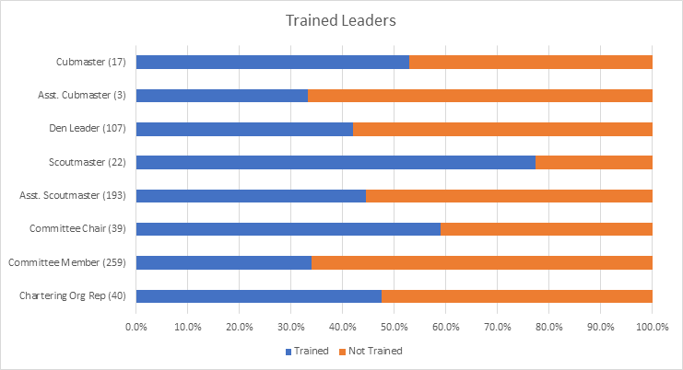

* + *Upcoming Training Opportunities*
    - 09/13/21 & 09/18/21 - **Leave No Trace/Outdoor Ethics**, Virtual/Germantown, MD
    - 09/18/21 - **SM/ASM Position Specific Training**, Bethesda, MD
    - 09/18/21 - Cub Scout Leader Specific Training (CM/ACM, DL, Committee), St Mark's, Vienna, VA
    - 09/20/21 - **Leave No Trace Trainer Course** – Outdoor Ethics, Frederick, MD
    - 09/24/21 - 09/26/21 - **Basic Adult Leader Outdoor Orientation (BALOO)**, Stafford, VA
    - 09/25/21 - 09/26/21- **Basic Adult Leader Outdoor Orientation (BALOO)**, Haymarket, VA
    - 09/25/21 - 09/26/21 - **Climbing Level 1 Instructor Training (16 year old and above)**, Sugarloaf, Dickerson, MD
    - 09/25/21 - **Back Country Outdoor Leadership School (BCOLS)**, Alexandria, VA
    - 09/25/21 - **Cub Scout Leader Specific Training** (CM/ACM, DL, Committee Members), Herndon, VA
    - 10/01/21 - 10/02/21 - **Basic Adult Leader Outdoor Orientation (BALOO)**, Haymarket, VA
    - 10/02/21 - **COR Training**, Marriot Scout Center, Bethesda, MD
    - 10/11/21 & 10/16/21 - **Leave No Trace/Outdoor Ethics (Trainer Course)**, Haymarket, VA  
      10/16/21 - **Basic Adult Leader Outdoor Orientation (BALOO)**, Reston, VA
    - 11/06/21 - 11/07/21 - **Introduction to Outdoor Leadership Skills (IOLS)**, Haymarket, VA
    - *Take Aways*
    - Training can be:
    - On-line
    - In-person
    - Can be both
    - Only YPT is Required – rest is optional
    - One BALOO trained adult is required for Cub Scout Packs to go camping.
    - Roundtable – great place to find out about Training opportunities.

1. **Program / Matt B**
   * Current 2021 GM Calendar
   * September 25, 2021 – Life to Eagle Seminar
   * October 15-17, 2021 – GM District STEM Camporee
   * October 16, 2021 – Jamboree on the Internet/ Jamboree on the Air
   * November 6, 2021 – Scouting for Food Tag Distribution
   * November 7, 2021 – Veterans Day Flags In
   * November 13, 2021 – Scouting for Food Pick Up
   * Civic and Related Activities of Interest to Scouts
   * National Public Lands Day – September 25 – Great Falls National Park – Free admission so visitors can enjoy national parks during this celebration of the National Public Lands Day.
   * Falls Church Fall Community Clean Up – Date TBD – Another service project opportunity benefitting the community.
   * Falls Church Halloween Carnival – Saturday, October 30 – For youth, 11 and under at the Community Center.
   * Falls Church – A Very Victorian Christmas – Visit the Cherry Hill Farmhouse to see how Christmas was celebrated in the 1860s.
   * Fairfax City Festival of Lights and Carols – December 4 from 12 to 6 p.m. in Old Town Square, 10415 North Street
   * National Public Lands Day – September 25 – Great Falls National Park – Free admission so visitors can enjoy national parks during this celebration of the National Public Lands Day.
   * Falls Church Fall Community Clean Up – Date TBD – Another service project opportunity benefitting the community.
   * Falls Church Halloween Carnival – Saturday, October 30 – For youth, 11 and under at the Community Center.
   * Falls Church – A Very Victorian Christmas – Visit the Cherry Hill Farmhouse to see how Christmas was celebrated in the 1860s.
   * Fairfax City Festival of Lights and Carols – December 4 from 12 to 6 p.m. in Old Town Square, 10415 North Street
   * Changes in Guide to Advancement
   * 2021 Guide to Advancement (GTA) supersedes the 2019 edition.
   * 2021 Guide had numerous small changes from 2019 Guide.
   * Only highlighting here changes that are of greatest impact.
   * If anyone has questions or is uncertain about how to apply the 2021 Guide to Advancement to a specific situation, please contact Matt Burns, George Mason Advancement Chair.
   * *Cub Scouts*
     + Exchanged references to Den Leader Guides with Scoutbook’s Den Leader experience meeting plans and resources
     + Identified Scoutbook as the official record of the den and pack
     + Simplified the approval process
     + Removed constraints on the frequency and length of den meetings
     + Cubs must earn Webelos rank before starting Arrow of Light adventures.
     + Cubs who are home-schooled should work on the rank that relates to their age.
     + Make sure the Cub can complete AOL before joining Scouts BSA
     + *Retiring Cub Adventures* - Not part of 2021 GTA changes but a 2022 program change

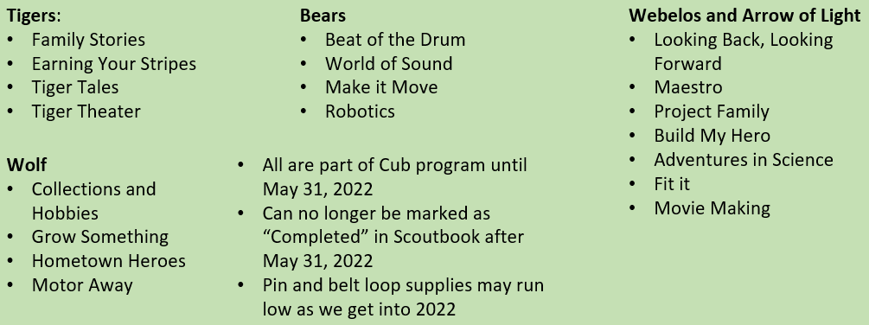

* + - *Scouts BSA*
    - *Rank advancement*
    - Virtual Scoutmaster conferences are OK but not preferred
    - NCAC now (9/8/21) authorized video-conference boards of review for Eagle.
    - Scout now have twenty-four (24) months after their 18th birthday or end of extension, whichever comes later, to have their Eagle Board of Review. 2019 Guide allowed 3 months.
    - After 24 months, Scout must file a Belated Rank Application.
    - Must be approved by National.
    - *Extensions and Palms*
    - Scouts can request extensions of time to earn Eagle, Summit and Quartermaster
    - We covered new extension request process earlier in 2021.
    - It was incorporated in the 2021 GTA
    - Scouts that earn merit badges during an approved extension request can use those merit badges to qualify for Palms, even though badges were earned after their 18th birthday.
    - *Merit Badges*
    - 2021 GTA recommends, but does not require, using Scoutbook’s digital system and “Blue Cards” to document Scout progress.
    - Electronic forms of merit badge reporting (non-Blue Card) are acceptable if they track partial completions
    - All counselors, in all settings (virtual included) must be approved by Council as a merit badge counselor for the badge(s) being counseled. This includes Scoutmasters.
    - Changes in merit badge requirements will be found first on Scouting.org.
    - NCAC – specific – Merit badge counselors will need to be trained. New ones starting 11/1/21. Existing by 12/31/22.
    - Unit leaders are encouraged to have a conversation with the Scout about their Merit Badge experience. What did they learn; what did they like; how was the counselor? This information can be used to give feedback to or about the MBC.
    - *Other Scouts BSA Changes*
    - Stronger language regarding *no retesting.*
    - Unit leaders carefully select and train those who approve advancement.
    - Updated safety references for service projects
    - Communicable disease now acceptable reason to hold a video-conference board of review.
    - Scout *Must* not stage an Eagle Scout service project that primarily collects money.
    - Unit leaders must not ask Scouts to provide blue cards or other proof of merit badge completion for earned badges.
    - *Ventures*
    - Venturing, Discovery, Pathfinder and Summit are now ranks, not awards.
    - Registration in a Scouts BSA unit *no longer required* for a youth that has already reached First Class to complete Scouts BSA requirements.
    - “Multiple credit” section has been rewritten.
    - Venturing Boards of Review now must be *unanimous.*
    - Eagle extension rules/process also applies to Summit
    - Venture Scouts now have 24 months after their 21rst birthday to participate in a Summit Board of Review.
  + District Adult Awards
    - Silver Beaver – Nominations due by October 31, 2021 for sustained superior service at the District level. Limit is at NCAC level.
    - District Award of Merit – Nominations due by December 31, 2021 for sustained superior service at the District level. George Mason can award two.
    - District awards committee will review nominations.
    - Anyone interested in putting forward a candidate should submit the adult volunteer’s name/rationale to [gm.adultrecognition@gmail.com](mailto:gm.adultrecognition@gmail.com) by September 30, 2021.
  + Flags In (Veterans Day – November 7, 2021)
  + Social distancing – bring a mask.
  + National Memorial Park, 7482 Lee Highway, Falls Church
  + All Scouts, including Girl Scouts, are welcome.
  + Class A Uniforms
  + For more info, contact Russell Pittman at [ruspittman@gmail.com](mailto:ruspittman@gmail.com)
  + District Life to Eagle Seminar (Virtual)
    - Saturday, 25 September 2021 from 1:00 p.m. to 4:00 p.m.
    - Registration: <https://site.corsizio.com/c/60eefcdba647dcba68c93d8e>
    - Who should attend:
    - Life Scouts or advanced Star Scouts who want to pursue the Eagle Rank
    - Eagle advisors, coaches or unit leaders that haven’t attended a seminar in two years
    - Parents of Scouts working on Eagle or other adults interested in Scouting
    - Registration - will be done online and must be received by 23 September 2021 to get the Zoom link.
    - Any questions contact Jack Lundin at 703-938-0369.
  + Fall 2021 District Camporee
    - District will hold its next Camporee on October 15-17, 2021.
    - Location – 4H in Front Royal
    - Theme - STEM
  + Online registration available [here](https://scoutingevent.com/082-49459)
  + Leader Guide available on registration site.
  + Need unit volunteers to help run event.
  + Camporee Director Andrew Zaso, (703) 434-2907 - AndrewZaso@gmail.com
  + Future Camporees
  + George Mason Spring 2022 Camporee – April 29 – May 1 – Theme/Site TBD
  + George Mason Fall 2022 Camporee – October 21 – 23, 2022 – Theme/Site TBD
  + Scouting for Food
  + November 6 (Tag Distribution) and November 13, 2021 (Food Collection)
  + Council can provide tags without a date for those Units that cannot do a Saturday distribution
  + Scott Willey is 2021 District Coordinator
  + High Adventure /Joe K
  + Hike-o-ree
    - Northern Virginia 4-H Educational Center, Front Royal, VA. Registration is limited to trail capacities of the fifteen trails.
    - Participation age is 13 years old as of January 1, 2022
    - Registration on a FIRST COME, FIRST SERVED BASIS begins on September 1, 2021, on the BSA National Capital Area Council website: https://scoutingevent.com/082-50574
    - Because of the lead-time required to produce the t-shirts, the final date to provide shirt numbers and sizes (S, M, L, XL, 2XL) is October 8. NO ADDITIONAL ORDERS CAN BE TAKEN AFTER THAT DATE.
  + Shooting Sports /Brian S
  + Requests for Shooting Events – Lead Time! (Contact [brian.summers@verizon.net](mailto:brian.summers@verizon.net))
  + 50+ scouts - 6mos
  + Less than 50 scouts - 3mos
  + Shooting on private land?
  + Requirements need to be followed
  + Permissions/protocols to be followed
  + Shooting Sports [web page](https://www.scouting.org/outdoor-programs/shooting-sports/)
  + Shooting Sports Instructor Classes:
  + [Rifle/Shotgun](https://www.ncacbsa.org/george-mason/district-resources/merit-badges/rifle-shotgun-training/)
  + [Archery](https://www.ncacbsa.org/george-mason/district-resources/merit-badges/archery-training/) (Virtual classes available)
  + Shooting Sports Committee will support the Camp Snyder Expos in October/November.
  + COPE and Climbing /John L
    - Don’t forget the District’s various COPE and Climbing Opportunities!
    - Where CUB Scouts learn about teamwork by playing Games with a Purpose
    - Boy and Girl Scouts learn how to lead their peers while playing these games.
    - And our more senior Scouts, Venturers, and Scouter’s practice and refine their skills through Challenge Outdoor Fun-Filled Family Engaged Experiences & Team Enhancing Activities (a.k.a. COFFFEE & TEA)
    - Level 1 & Level 2 training in COPE & Climbing programs need to be coordinated with COPE & Climbing committee chair: Tony Waisanen ([ncac.cope@gmail.com](mailto:ncac.cope@gmail.com))
    - Interested in obtaining a deck of COFFFEE & TEA game cards, E-mail [JohnLesko57@gmail.com](mailto:JohnLesko57@gmail.com)
  + Merit Badges /Margee E
  + Every merit badge counselor needs to be on the District Charter.  The time for action is NOW!
  + The online Merit Badge Counselor [registration](https://my.scouting.org/VES/OnlineReg/1.0.0/?tu=UF-MB-082gm23) works for all Scouters who do not already hold another District position.  If you are already registered for a district position, you will not be able to use the electronic registration. Please use the [paper form](https://3.basecamp.com/3958009/buckets/13968082/uploads/4137345739).
  + Be sure the counselor uses his/her legal name – no nicknames.
  + Merit Badge Counselors, or the unit Dean/Leader, also need to scan and send Margee the [Merit Badge Counselor application](https://filestore.scouting.org/filestore/pdf/34405.pdf) form listing the badges the counselor is applying to teach and providing a justification of his/her qualifications.
  + Youth Protection Training is the essential first step.  Do not hit “send” on the application without it!
  + Contact Margee if you have questions at GM.MB.Dean@hotmail.com.

1. **Order of the Arrow (OA)**
   * OA had a live Roundtable tonight. They were discussing moving the OA Roundtable to the first Thursday of the month.
   * [Fall Fellowship](https://scoutingevent.com/082-49142) (9/24 - 9/26) at Camp Snyder.
   * Area Ordeal (10/1 – 10/3) and Brotherhood at Camp Snyder.
2. **Other Announcements**

* iContact – NCAC is implementing a new email list server for the districts. They are prepopulating the lists with adult registrations.
* [Distinguished Eagle Scout Award](https://www.scouting.org/awards/awards-central/Distinguished-Eagle/) – This award recognizes Eagle Scouts who earned their award 25 years or more ago and have achieved national-level prominence in their field. Nominations can be submitted to the National Eagle Scout Association (NESA).
* Arrow of Light – If a youth joins scouting while in the fifth grade, they can start on their AOL. However, if the youth is in the fourth grade, they must finish Webelos first.

1. **District Executive Minute /Jose Calil**
   * Thank you for all you do.
   * Will be adding JSN dates to the Scouting Tracker. Still missing a few dates. I will reach out to those units.
   * Basecamp site setup for Charter Renewal. I will add the Unit Leaders to that site.
2. **District Chair /John K**

* Have established at spreadsheet with contact information for Unit Leaders. You can go to Basecamp to access/update the information.
* Change – There has been a lot of change in the last year and still a lot ahead. Matt talked about Advancement changes, Hector talked about Charter Renewal and other challenges. Be prepared.

1. **District Commissioner Minute /Hector U**
   * Be prepared for changes that are coming.
   * Please watch for the announcement of training on Charter Renewal.
2. **Minutes and Slides** – Will be available on the GMD Web Site (District Resources, Roundtable).
3. **Next meeting** – October 14, 2021, at 7:30pm