Roundtable
November 11, 2021

- Council Update /Hector U
  - Charter Renewal – Getting it done in a timely manner is the goal!
  - Internet Rechartering Status as of November 8, 2021:
    - 14 units out of 40 (35%) have submitted their charter renewal application online
      - 1 of those has pre-posted
      - 13 are being reviewed by the registrar (on-hold)
    - 21 units out of 40 (53%) have started the online process for renewing their charters - we need these units to submit the application.
    - Five units have not started the process - we need these five units to start the Charter Renewal process in the new system.
  - "On Hold" status means the registrar has the file and needs to review any attachments or other paperwork.
  - Remember, the goal is to recharter the unit; you can always submit applications after your charter renewal application is submitted.
  - Only paper required is the Annual Charter Agreement and the paper check made out to NCAC-BSA (if paying by check). You can turn these into your Unit Commissioner.
  - May want to turn in your annual Journey to Excellence at the same time.

- Big Rock – What can the District do for you? /John K & Rus Pittman
- Want to provide an overview of the District functions at this meeting. We will be asking you for help in deciding what we should start, stop or continue as a District. We will discuss this further at the December Roundtable meeting.

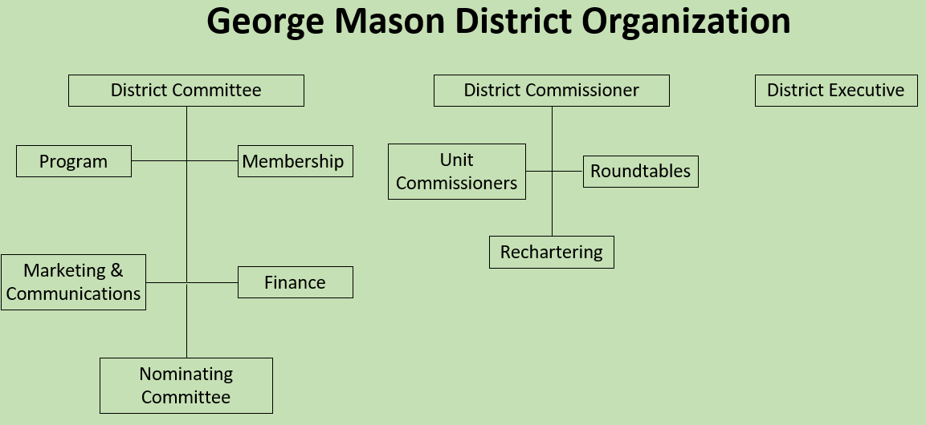
- District Committee supports:
  - Program
  - Membership (recruit, retain)
  - Marketing and Communications
  - Finance (FOS, Popcorn, Activities), and
  - Nominating Committee
- District Commissioner supports:
  - Unit Commissioners (Support unit growth & retention, support leaders, link needs)
  - Roundtables (Contact units, link needs, share information and fellowship)
  - Recharter
- District Executive - The professional Scouter who works under the direction of the Scout executive and is responsible for providing direct service to the district.
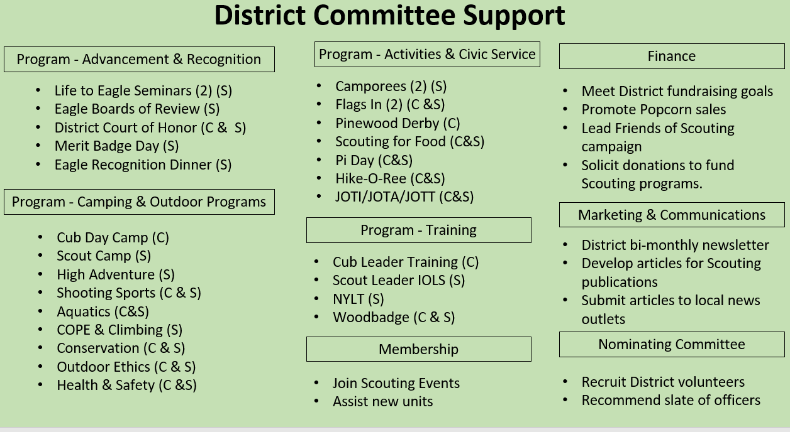

  - What are the Unit Needs?
  - What elements of the District program do we need to continue? Start? Stop?
  - How do unit leaders see their unit’s role in supporting the District? What constitutes unit support?
  - What can we do to promote greater participation in Cub Scout camps?
  - How can we better support Cub units?
  - What can we do to improve recruiting new Cubs, Scouts and volunteer leaders?
  - How do we increase the percentage of fully trained leaders among our Cub and Scouts BSA units?
  - What can we do to communicate better?
  - District Advancement & Recognition Activities
  - Life to Eagle Seminars (2) (S)
  - Lion/Tiger Graduation (C)
  - District Court of Honor (C&S)
  - Merit Badge Day (S)
  - Eagle Recognition Dinner (S)
  - District Volunteer Recognition Dinner/Picnic (inc. Dist. COH)
  - What ideas do you have/what do you see is of value?
  - District Activities
  - Camporees (2) (S)
  - Fishing Derby (C)
  - Pinewood Derby (C)
  - Haunted Woods (C)
  - Pi Day (C&S)
  - Water Carnival (C)
  - Hike-O-Ree (C&S)
  - Webelos Woods (C)
  - JOTI/JOTA/JOTT (C&S)
  - Family Camp (C)
  - District Games (C&S)
  - Klondike Derby (S)
  - Winterberg (S)
  - What ideas do you have/what do you see is of value?
  - District Civic Service
  - Flags In (2) (C &S)
  - Scouting for Food (C&S)
  - Earth Day Service (C&S)
  - Day of Giving (C&S)
  - Charter Organization Service Day (Scouting Anniversary) (C&S)
  - What ideas do you have/what do you see is of value?
  - District Training
  - Scheduled In Person/Zoom Cub Leader Training (C)
  - Hosted In Person/Zoom Cub Leader Training (C)
  - Scout Leader IOLS (S)
  - BALOO (C)
  - What ideas do you have/what do you see is of value?
  - Roundtable
  - What elements of the Roundtable program do we need to continue? Start? Stop?
  - How do unit leaders see their unit’s role Roundtable? Participants, Planners, Speakers, Panelist?
  - Should we continue Zoom even when we have in-person meetings?
  - What can we do to promote greater participation?
  - Are there topics/areas of interest that we never seem to cover?
  - What ideas do you have/what do you see is of value?

- Program / Matt B
  - Current 2021-2022 GM Calendar
  - November 13, 2021 – Scouting for Food Pick Up
  - January 29, 2022 – Life to Eagle Seminar
  - March 5, 2022 – GM Merit Badge Day
  - March 14, 2022 – Pi Day
  - March 19, 2022 – GM Pinewood Derby
  - April 14, 2022 – GM District COH
  - April 29 to May 1, 2022 – GM Spring Camporee
  - May 1 to May 15, 2022 – GM Hike-O-Ree
  - May 14, 2022 – Jamboree on the Trail
  - May 30, 2022 – Flags In

  - Scouting for Food
  - Tag Drop-off: Had a strong turnout from George Mason Packs and Units
  - Pick-up: November 13, 2021
  - Service Hours: Remember to log the service hours contributed by youth/adult volunteers https://www.ncacbsa.org/scouting-for-food-unit-data/
  - Basecamp: Check site for any special instructions unique to the food pantry assigned to your unit dropping off a
  - 2021 District Coordinator: Scott Willey
  - From Scott: “Please convey my sincere thanks to all the units for participating in this service project!”

  - Pi Day – Monday, March 14, 2022
  - Open to all (Cubs, Scouts BSA and Venturing Scouts)
  - Pi Day gives math enthusiasts the opportunity to celebrate their love for numbers and the enigma that is the infinite Pi.
  - March 14 also is Albert Einstein’s birthday.
  - Pi is the ratio of a circle’s circumference to its diameter. Amazingly, for all circles of any size, Pi will always be the same.
  - One can celebrate “Pi Day” with any kind of pie – pizza, apple, cherry, Boston Crème pie, etc. Let your imagination be your guide!
  - Stay tuned for more “Pi Day” activities as we get closer to the big day!

  - 2022 GM Pinewood Derby
  - Race Day is March 19, 2022
  - All Packs wanting to participate in the 2022 Pinewood Derby MUST hold their Pack Pinewood Derbies by March 10, 2022.
  - One unit winner from each age bracket (Lions, Tigers, Wolves, etc.) regardless of gender.
  - Pack winners must register (and pay) on Council website. $15.00 per entry. No money collected at door on day of race. Must register by 3/17/22.
  - Register at https://scoutingevent.com/082-52774
  - Race will be held at Fairfax Presbyterian in Fairfax.
  - For questions, contact Chip McCaslin at chipmccaslin@gmail.com

  - District Court of Honor
  - To recognize adults who served/are serving at the unit level.
  - Two types of awards:
  - Unit Commissioner’s Unit Scouter Award – Limited to one (1) per unit
  - Unit Appreciation Award – Maximum 8 per unit.
  - Please provide a sentence or two describing the individual’s service.
  - Submit Unit Commissioner’s Unit Scouter Award to Unit Commissioner.
  - Unit Appreciate Award to gm.adultrecognition@gmail.com
  - Must have all submissions by no later than March 11, 2022.
  - Will confer awards at District COH/April Roundtable.

  - George Mason Hike-O-Re
  - 2nd Annual GM Hike-O-Ree on weekends of May 7 and May 14 – 5/6/22 to 5/15/22.
  - Open to all (Cubs, Scouts BSA and Venturing Scouts), families and friends.
  - Any age, any place and any appropriate grouping – just keep track of how far you hiked.
  - Register on Council website (registration opening in early 2022). $5.00 for a patch.
  - Challenge – District Scouts, Scouters and families hike 2,022 miles.
  - Total the miles for each unit and notify Matt Burns at Burnsmj509@gmail.com. We’ll see how big a total we reach.

  - Civic and Related Activities of Interest to Scouts
  - Dyke Marsh Sunday Morning Bird Walks – 8:00 a.m. on Sundays at Dyke Marsh in Alexandria
  - Huntley Meadows Monday Morning Bird Walk - at 7:00 a.m. in Alexandria
  - Native American Campfire Cookout – 11/14/21 & 11/28/21 at 2:00 p.m. Riverbend Park in Great Falls. $12 per person.
  - Hot Dogs, Smores! Wagon Ride & Campfire – 11/17/21 at 5:00 p.m. Ellanor C. Lawrence Park $10 per person.
  - Fairfax Holiday Craft Show – 11/20/21 (10-5) & 11/21/21 (10 – 3) at Fairfax High School
  - Vienna Church Street Holiday Stroll - 11/29/21 from 6 – 8:30 p.m.
  - Falls Church – A Very Victorian Christmas – 11/27/21 – Cherry Hill Farmhouse.
  - Falls Church – Holiday Craft Show – Falls Church Community Center
  - Bull Run Festival of Lights – Bull Run Regional Park until 1/2/22.
  - Vienna VA - Meadowlark’s Winter Walk of Lights – 11/11/21 to 1/2/22
  - Photo With Santa – 11/27/21 – 11:00 a.m. at Sully Historic Site.
  - Flying Squirrels – Gliding in Tonight – 11/28/21 at 5:30 p.m. Hidden Oaks Nature Center
  - Fairfax City Festival of Lights and Carols – 12/04/21 from 12 to 6 p.m. in Old Town Square, 10415 North Street
  - Pet Photos with Santa – Mondays at Springfield Town Center until 12/20/21.
  - Photos with Santa - at Springfield Town Center through 12/21/21.
  - X-Wing Starfighter from “Star Wars” – On display through 01/01/22 at National Air and Space Museum, Udvar-Hazy Center, Dulles
  - Friday Night Sky Watching - at the Turner Farm Park’s Roll-Top Observatory in Great Falls, VA.
  - Fairfax Chocolate Lovers Festival - 2/4/22 to 2/6/22

  - Training /Roy D
  - Unit Training – For position-specific training at your unit,
contact Roy De Lauder at EagleScout.Roy@cox.net or
go to Training opportunities page on GM Web Site.
  - Scouts BSA Training
    - 11/20/21 - Scoutmaster Specific Training, Alexandria, VA
    - 11/20/21 - Wilderness First Aid, Camp Snyder, Haymarket, VA
    - 12/04/21 - Scoutmaster Specific Training, Alexandria, VA
    - 12/18/21 - Wilderness First Aid, Camp Snyder, Haymarket, VA
    - 01/14-17/22 & 01/21-23/22 – NYLT (Winter), Camp Snyder
  - Cub Scout Training
  - 11/20/21 - Akela’s Trail (was POW-WOW; Virtual), Bethesda, MD
  - All
  - 12/04/21 – Trainer’s Edge, Reston, VA
  - 02/26/22 – University of Scouting, Alexandria, VA

  - District Life to Eagle Seminar
  - Saturday, January 29, 2022, from 1pm – 4pm (Virtual)
  - Register at: https://scoutingevent.com/082-52778
  - Any questions contact Jack Lundin at 703-938-0369.

  - Spring 2022 District Camporee
    - District will hold its next Camporee on April 29 – May 1, 2022.
    - Location and Theme – TBD
  - Need unit volunteers to help run the event
  - Leader Guide will be available on the registration site a few weeks ahead of the event.
  - Camporee Director Andrew Zaso, (703) 434-2907 - AndrewZaso@gmail.com

  - Future Camporees
  - George Mason Fall 2022 Camporee – October 21 – 23, 2022 – Theme/Site TBD
  - George Mason Spring 2023 Camporee – May 5 – 7, 2023 – Theme/Site TBD

  - Citizenship in Society Merit Badge
  - New merit badge encourages Scouts to explore important topics around diversity, equity, inclusion and ethical leadership and learn why these qualities are important in society and in Scouting.
  - Beginning July 1, 2022, the Citizenship in Society merit badge will be required for any youth seeking to earn Eagle.
  - NCAC is working on the requirements/process to approve Citizenship in Society merit badge counselors.
  - We strongly recommend units review roster and identify 17-year-old Life Scouts working on Eagle.
  - Life Scouts need to either finish all Eagle requirements through Scoutmaster conference (but not Board of Review) by June 30, 2022, or plan enough time to earn Citizenship in Society.

  - 2022 District Merit Badge Event
  - March 5th, 2022, at Fairfax Presbyterian Church in Fairfax.
  - Registration will open on December 23, 2021
  - Need Unit Merit Badge Day Coordinator names and contact details by November 30 to John Drisco at gmasonmeritbadgeday@gmail.com
  - Encourage Scouts to get merit badge books by December 31. Read requirements and start tackling “pre-work” by early January 2022.
  - Note: The “pre-work” is not the same as a “prerequisite.” The “pre-work” consists of tasks/activities that the Scout is advised to do in advance of the Merit Badge Day. A Scout can still participate in the Merit Badge Day class if he hasn’t completed the pre-work but failure to complete the pre-work may mean the Scout leaves the Merit Badge Day with a partial badge. A prerequisite is something that must be done in order to qualify to take the class. The only prerequisite we are aware of for the George Mason Merit Badge Day is that the Scout must be a registered member of the Boy Scouts in a participating unit.
  - Feedback to John Drisco at gmasonmeritbadgeday@gmail.com

  - Merit Badges /Margee E
  - Every merit badge counselor needs to be on the District Charter. The time for action is NOW!
  - The online Merit Badge Counselor registration works for all Scouters who do not already hold another District position.
  - New Merit Badge Counselors must complete online merit badge counselor training, in addition to YPT, after November 1, 2021. Existing merit badge counselors have until 12/31/22 to complete training.
  - Be sure the counselor uses his/her legal name – no nicknames.
  - Merit Badge Counselors, or the unit Dean/Leader, also need to scan and send Margee the Merit Badge Counselor Information Form listing the badges the counselor is applying to teach and providing a justification of his/her qualifications.
  - Youth Protection Training is the essential first step. Don’t hit “send” on the application without it!
  - Contact Margee if you have questions at GM.MB.Dean@hotmail.com.

  - Shooting Sports /Brian S
  - Requests for Shooting Events – Lead Time! (Contact brian.summers@verizon.net)
  - 50+ scouts - 6mos
  - Less than 50 scouts - 3mos
  - Shooting on private land?
  - Requirements need to be followed
  - Permissions/protocols to be followed
  - Shooting Sports web page
  - Shooting Sports Instructor Classes:
  - Rifle/Shotgun
  - Archery (Virtual classes available)
  - Shooting Sports Committee will support the Camp Snyder Expos in October/November.
  - Shooting Sports classes will be coming to Camp Snyder (with the shooting portion at local clubs). More information will be available soon.

  - COPE and Climbing /John L
    - Don’t forget the District’s various COPE and Climbing Opportunities!
    - Where CUB Scouts learn about teamwork by playing Games with a Purpose
    - Boy and Girl Scouts learn how to lead their peers while playing these games.
    - And our more senior Scouts, Venturers, and Scouter’s practice and refine their skills through Challenge Outdoor Fun-Filled Family Engaged Experiences & Team Enhancing Activities (a.k.a. COFFFEE & TEA)
    - Level 1 & Level 2 training in COPE & Climbing programs need to be coordinated with COPE & Climbing committee chair: Tony Waisanen (ncac.cope@gmail.com)
    - Interested in obtaining a deck of COFFFEE & TEA game cards, E-mail JohnLesko57@gmail.com

  - Scholarships
  - BSA Scholarship page - https://www.scouting.org/awards/scholarships/
  - Elks Most Valuable Scholar – Deadline Nov 15, 2021 https://www.elks.org/scholars/scholarships/MVS.cfm
  - Sons of American Revolution – Deadline Dec 15, 2021 Arthur M. & Berdena King Eagle Scout Contest – National Society Sons of the American Revolution (sar.org)
For more info/questions, contact Bill Denk at thinkdenk3@msn.com.
  - Campaign Pay it Forward – Deadline December 31, 2021, Free Scholarship (campaignpayitforward.com)
  - National Eagle Scout Association – Deadline January 31, 2022, Scholarships - The National Eagle Scout Association (nesa.org)

  - Glenn A. and Melinda W. Adams Award
  - Recognizes a noteworthy Eagle Scout Service Project.
  - Deadline is January 21, 2022
  - Anyone can make a nomination. ADAMS-NATIONAL-EAGLE-SCOUT-SERVICE-PROJECT-OF-THE-YEAR-NOMINATION-FORM.pdf (nesa.org)
  - Scout must sign application to document their “consent.”
  - Also needs an electronic copy of the project workbook.
  - Some nominations include video.
  - Winners can receive:
  - $500 at the Council level.
  - $500 at the Regional (Northeast) level.
  - $2,500 for National winner.

- Order of the Arrow (OA) /Brian S
- Ordeal – Had 21 new members this year.
- Brotherhood – Had 11 go through the Brotherhood ceremony.

- Other Announcements
- American Legion Eagle Scout Scholarships – Opening soon.

- District Executive Minute /Jose Calil
  - Let me know if you need anything.

- District Chair /John K
- Good to see all of you in-person. It has been a long time.
- Annual Meeting Nominations – We will be voting on any nominations at the Annual Meeting on 11/17/21 (Virtual). Only recommendations from the Nominating Committee will be voted on. Get your nominations in by 11/16/21.
- Friends of Scouting – Will start the 2022 FOS drive at the Annual Meeting.

- District Commissioner Minute /Hector U
- Commissioners – Your Unit Commissioners are a resource to assist you. Please ask if you have questions or need help with an issue.
- Recharter – Check the Basecamp site for updated information.

- Minutes and Slides – Will be available on the GMD Web Site (District Resources, Roundtable).

- Next meeting – December 9, 2021, at 7:30pm at Thoreau MS

