Roundtable
December 09, 2021

- Council Update /Hector U
  - Charter Renewal Status (as of 12/07/21)
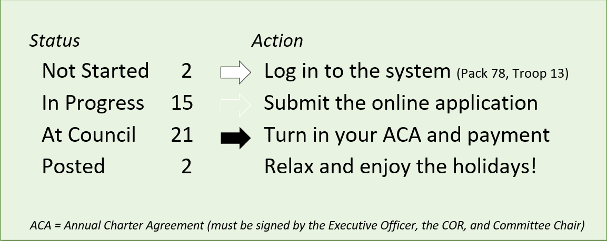
  - In addition to submitting the online application, units need the Annual Charter Agreement (signed by the Institutional Head, Committee Chair and Chartering Organization Representative) and the payment (online or check).

- Big Rock – What can the District do for you? /John K & Rus Pittman
  - Surveys sent out
  - (2) Cub units responded
  - (15) Scouts BSA units responded

  - 2022 Activities – Units plan to participate
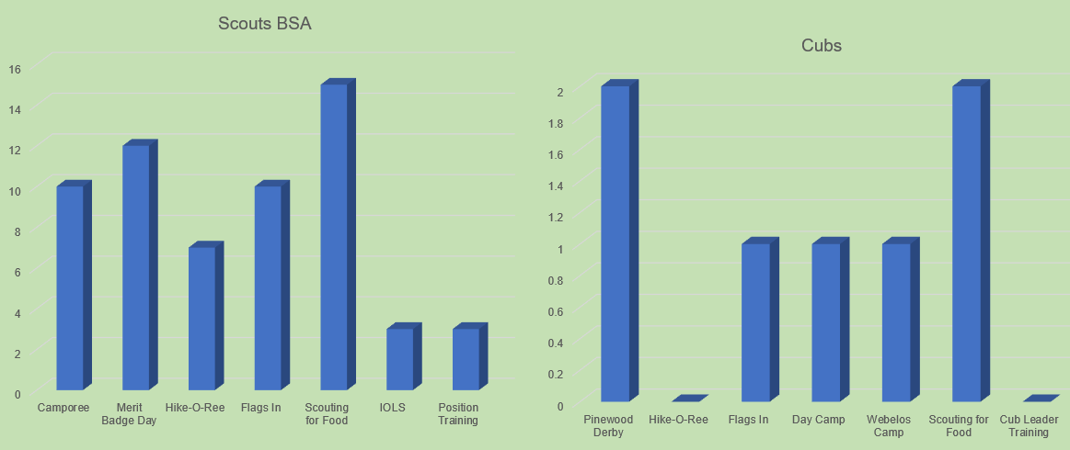

  - Activities to Add to GM Program
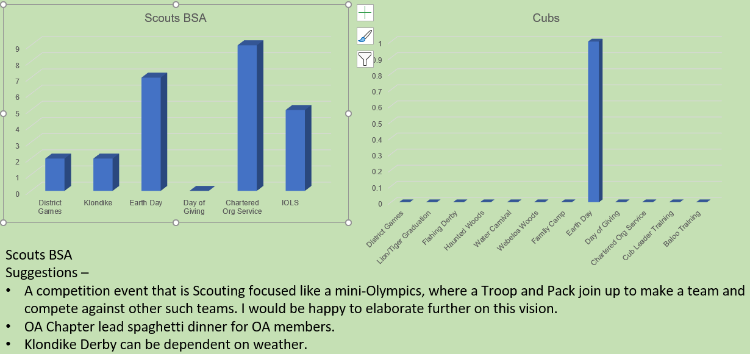

  - What Changes does your unit want in the GM Program?
  - Cubs – no responses
  - Scouts BSA
    - More interaction between Scouts and Packs, perhaps through group games, campouts, or some kind of joint activity, really build a relationship between the two. Unique activities and opportunities for the district, several years ago someone was able to bring a group of scouts to visit an embassy nearby. I thought that was pretty amazing and educational for all who attended.
    - Continue current program
    - Continue Flags In
    - More Scout led programs
    - Can’t think of anything now.
    - None at this time (2)
    - Start – Single point of contact for CCs and SMs for all items. Start – Single page how to Eagle with single point of contact for each Troop. Stop – Multiple e-mails per month.
    - Continue District MB Day
    - Continue – does not feel as if the District program needs to expand – lots of opportunities being offered and they begin to create conflicts with Unit program time.
    - Execute what you plan. Several times our Troop added a GM District event to our annual plan only for it to be cancelled. As a result, I’m hesitant to add District events to our annual plan.

  - How likely is your unit to supply volunteers for District Events?
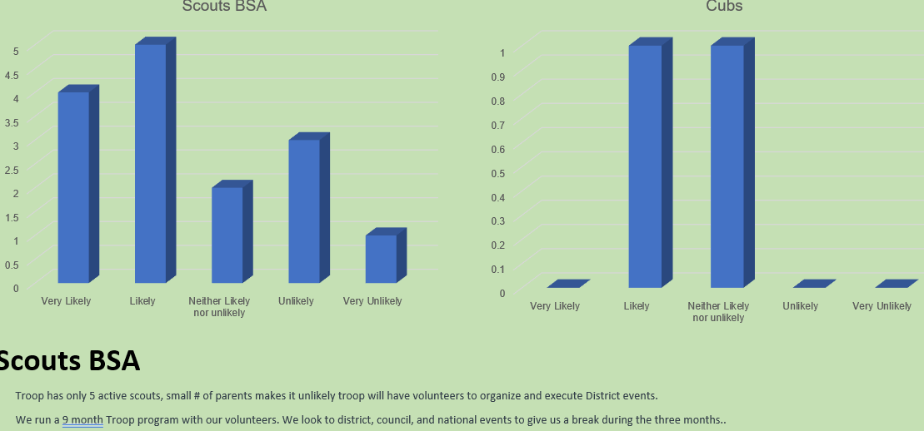

  - What is Unit’s Role in Supporting District?
  - Cubs – no response
  - Scouts BSA
    - We are all in it together but when troop size is small, it's the same folks doing everything so to add on additional volunteer work would be difficult I believe we are doing our part, admittedly everyone can do more.
    - We support district as we are able.
    - Very limited.
    - Supply volunteers to help with district events, participate in FOS, Scouting for Food, other service events.
    - Participate in Scouting for Food covering our unit’s assigned territory, attend district Spring and Fall camporee when possible (sorry we missed the CY21 Fall Camporee as our Scouts chose to attend Marshall High School homecoming event.)
    - By attending and supporting the district’s programs.
    - Efficient, non-repetitive communications would be helpful. Constant, multiple repetitive communications dilute attention to the communications – just stop looking at them.
    - A few well planned and executed district events each year.

  - Roundtable Attendance
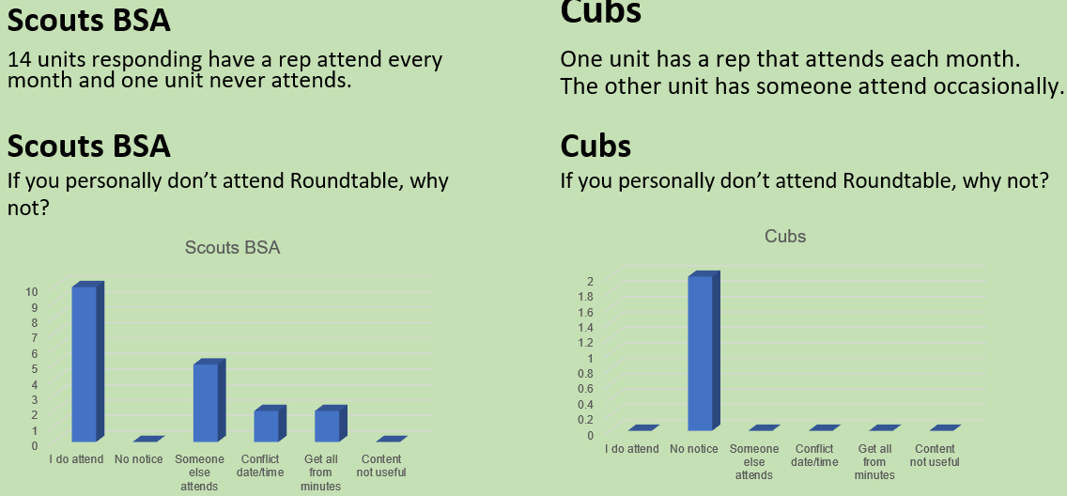

  - What Changes Would You Make to Roundtable?
  - Cubs – No Feedback
  - Scouts BSA
    - I'm not sure how it can be more useful besides maybe hearing from different Troops and Packs about their struggles and success stories that happened from the last roundtable. I have been going to the Roundtable for several years and unfortunately, I know little about what other troops are going through and I feel a like everyone is working in their own little silo. I was once in a Pack in Hawaii and every week we would get together to fellowship and several parents were assigned to bring lunch for the entire pack, I feel the activity of breaking bread together brought the Pack closer. I feel food brings people together and helps build better relationships. Maybe we can ask the RoundTable attendees if they would be interested in doing monthly potlucks. I envision breaking up the attendees and assigning each group to a particular month to be responsible to bring a home cooked meal or snack to share (No store-bought packaged meals). I'm sorry but cheese and cold cuts don't really do much for me like someone actually putting effort into cooking a small meal or snack. Ask Mark Serfass about his home-made lasagna.
    - More detail in minutes would be helpful.
    - If you could organize the Cub Scout related materials in one part and the Scouts BSA materials in another part and put the announcements in the middle that would be helpful. The Scouts BSA information usually is of limited interest to the Cub Scout people.
    - Our CO only provides meeting space on Thursday nights. Scoutmaster listens into Roundtable stream while physically attending troop’s meeting.
    - Content at roundtable is very helpful. Cub scout topics are less relevant to troops and vice versa (not sure how you can really change that, though). If meetings could be kept to an hour, that would be ideal (although has no bearing on usefulness to the unit). Please keep zoom option as sometimes it is not feasible to attend in person. Minutes are detailed and provide lists of dates (this is a good thing) but attending is better, even if virtual.
    - More sharing of ideas for activities.
    - Split into two meetings on the same night. Earlier for Cub Scouts and later for Scouts BSA. Do not present material that we already have in writing, just summarize. Keep meetings to one hour each with 30 minutes afterwards for leaders to stay and ask questions.
    - None (3).
    - It would be nice if it were an hour long as in the past.
    - I think the District does a pretty good job of supporting my unit.

    - Other Comments
  - Can we get more feedback – We are open to people giving additional feedback. Contact your unit commissioner, the RT commissioner, or the District Chair.
  - How to get more buy-in for district events? Could we have scouts participate in the planning?
  - Other districts have a Roundtable for youth
  - Roundtable should be a discussion – rather than a Big Rock, just have leaders throw out some issue/concern they have and get feedback from others.
  - Panels (with structure) seem to be well received.
  - We could have the group suggest topics for the Big Rock/structured discussion

- International Peace Light (12/13/21 @ 7:30pm) – Fairfax United Methodist Church, 10300 Stratford Avenue, Fairfax, VA
  - The Peace Light, symbolic of the Light of Christ especially evident at Christmas, is meant to promote peace, harmony, and unity among all people of the world regardless of race, ethnicity, or creed. The Peace Light makes its long journey from the Grotto of the Nativity in the Town of Bethlehem, to Tel Aviv, Israel, to Vienna, Austria and finally safely across the Atlantic Ocean to New York City. Peace Light North America supporters move the Light person-to-person, lantern-to-lantern, across North America and around their local areas, actively promoting global peace.
  - 2021 Peace Light will arrive in Fairfax this Saturday, and the troop will be sharing it with the Scouting community at our Court of Honor on Monday, December 13 at 7:30pm at Fairfax United Methodist Church.

- Program / Matt B
  - Current 2022 GM Calendar
  - January 29, 2022 – Life to Eagle Seminar
  - March 5, 2022 – GM Merit Badge Day
  - March 14, 2022 – PI Day
  - March 19, 2022 – GM Pinewood Derby
  - April 14, 2022 – GM District COH
  - April 29 to May 1, 2022 – GM Spring Camporee
  - May 1 to May 15, 2022 – GM Hike-O-Ree
  - May 14, 2022 – Jamboree on the Trail
  - May 30, 2022 – Flags In

  - Scouting for Food
  - Thanks to all units for participating in 2021 Scouting for Food.
  - George Mason units collected over 50,476 pounds of food.
  - Food pantries in our area are deeply appreciative. Needs were very high in 2021.
  - Please remember to log the service hours contributed by youth and adult volunteers.

  - Pi Day – Monday, March 14, 2022
  - Open to all (Cubs, Scouts BSA and Venturing Scouts)
  - Pi Day gives math enthusiasts the opportunity to celebrate their love for numbers and the enigma that is the infinite Pi.
  - March 14 also is Albert Einstein’s birthday.
  - Pi is the ratio of a circle’s circumference to its diameter. Amazingly, for all circles of any size, Pi will always be the same.
  - One can celebrate “Pi Day” with any kind of pie – pizza, apple, cherry, Boston Crème pie, etc. Let your imagination be your guide!
  - Stay tuned for more “Pi Day” activities as we get closer to the big day!

  - 2022 GM Pinewood Derby
  - Race Day is March 19, 2022
  - All Packs wanting to participate in the 2022 Pinewood Derby MUST hold their Pack Pinewood Derbies by March 10, 2022.
  - One unit winner from each age bracket (Lions, Tigers, Wolves, etc.) regardless of gender.
  - Pack winners must register (and pay) on Council website. $15.00 per entry. No money collected at door on day of race. Must register by 3/17/22.
  - Register at https://scoutingevent.com/082-52774
  - Race will be held at Fairfax Presbyterian in Fairfax.
  - For questions, contact Chip McCaslin at chipmccaslin@gmail.com

  - District Court of Honor
  - To recognize adults who served/are serving at the unit level.
  - Two types of awards:
  - Unit Commissioner’s Unit Scouter Award – Limited to one (1) per unit
  - Unit Appreciation Award – Maximum 8 per unit.
  - Please provide a sentence or two describing the individual’s service.
  - Submit Unit Commissioner’s Unit Scouter Award to Unit Commissioner.
  - Unit Appreciate Award to gm.adultrecognition@gmail.com
  - Must have all submissions by no later than March 11, 2022.
  - Will confer awards at District COH/April Roundtable.

  - George Mason Hike-O-Re
  - 2nd Annual GM Hike-O-Ree on weekends of May 7 and May 14 – 5/6/22 to 5/15/22.
  - Open to all (Cubs, Scouts BSA and Venturing Scouts), families and friends.
  - Any age, any place, and any appropriate grouping – just keep track of how far you hiked.
  - Register on Council website (registration opening in early 2022). $5.00 for a patch.
  - Challenge – District Scouts, Scouters and families hike 2,022 miles.
  - Total the miles for each unit and notify Matt Burns at Burnsmj509@gmail.com. We’ll see how big a total we reach.

  - Civic and Related Activities of Interest to Scouts
  - Dyke Marsh Sunday Morning Bird Walks – 8:00 a.m. on Sundays at Dyke Marsh in Alexandria
  - Huntley Meadows Monday Morning Bird Walk at 7:00 a.m. in Alexandria
  - Falls Church – Holiday Craft Show – Falls Church Community Center
  - Bull Run Festival of Lights – Bull Run Regional Park until 1/2/22.
  - Vienna VA - Meadowlark’s Winter Walk of Lights – 11/11 to 1/2/22
  - Pet Photos with Santa – Mondays at Springfield Town Center until 12/20/21.
  - Photos with Santa at Springfield Town Center through 12/21/21.
  - X-Wing Starfighter from “Star Wars” – On display through Jan 1, 2022, at National Air and Space Museum, Udvar-Hazy Center, Dulles
  - Friday Night Sky Watching at the Turner Farm Park’s Roll-Top Observatory in Great Falls, VA.
  - Fairfax Chocolate Lovers Festival 2/4/22 to 2/6/22

  - District Life to Eagle Seminar
  - Saturday, January 29, 2022, from 1pm – 4pm (Virtual)
  - Register, by January 27, 2022, at: https://scoutingevent.com/082-52778
  - Any questions contact Jack Lundin at 703-938-0369.

  - 2022 District Merit Badge Event
  - March 5th, 2022, at Fairfax Presbyterian Church in Fairfax.
  - Registration will open on December 23, 2021
  - Need Unit Merit Badge Day Coordinator names and contact details by November 30 to John Drisco at gmasonmeritbadgeday@gmail.com
  - Encourage Scouts to get merit badge books by December 31. Read requirements and start tackling “pre-work” by early January 2022.
  - Note: The “pre-work” is not the same as a “prerequisite.” The “pre-work” consists of tasks/activities that the Scout is advised to do in advance of the Merit Badge Day. A Scout can still participate in the Merit Badge Day class if he hasn’t completed the pre-work but failure to complete the pre-work may mean the Scout leaves the Merit Badge Day with a partial badge. A prerequisite is something that must be done in order to qualify to take the class. The only prerequisite we are aware of for the George Mason Merit Badge Day is that the Scout must be a registered member of the Boy Scouts in a participating unit.
  - Feedback to John Drisco at gmasonmeritbadgeday@gmail.com

  - Spring 2022 District Camporee
    - District will hold its next Camporee on April 29 – May 1, 2022.
    - Location and Theme – TBD
  - Need unit volunteers to help run the event
  - Leader Guide will be available on the registration site a few weeks ahead of the event.
  - Camporee Director Andrew Zaso, (703) 434-2907 - AndrewZaso@gmail.com

  - Future Camporees
  - George Mason Fall 2022 Camporee – October 21 – 23, 2022 – Theme/Site TBD
  - George Mason Spring 2023 Camporee – May 5 – 7, 2023 – Theme/Site TBD

  - GM High Adventure
  - NCAC High Adventure Committee (HAC) updates and announcements: https://www.ncacbsa.org/high-adventure/
  - 2022 National High Adventure Base slots still available; 2023 registrations begin on 12 January
  - 2022 Lenhok’sin Canoe Trek provisional slots still available
  - Philmont Preparedness Seminars: https://www.philmontscoutranch.org/Philmont-prep-seminars
  - Updated HA Source Book (volumes I and II): https://3.basecamp.com/3958009/buckets/16000091/vaults/2777714268
  - New BSA Adventure Planning Resource: The Adventure Plan (TAP) https://tap.scouting.org/
  - Contact Joe Knecht at knechtjoe@yahoo.com if you have questions regarding high adventure planning or resources.

  - Training /Roy D
  - Unit Training – For position-specific training at your unit, contact Roy De Lauder at EagleScout.Roy@cox.net or go to Training Opportunities page on GM Web Site.
  - Back Country Outdoor Leadership Skills – 03/05/22 Huntingtown, MD
  - Cub Scout Leader – 01/22/22 – Herndon, VA
  - NYLT - 01/14-17/22 & 01/21-23/22 – Camp Snyder, Haymarket, VA
  - University of Scouting - 02/26/22 – Alexandria, VA
  - Wilderness First Aid
- 12/18/21 – Camp Snyder, Haymarket, VA
- 01/08/22 – Camp Snyder, Haymarket, VA
- 02/12/22 – Camp Snyder, Haymarket, VA
- 03/12/22 – Camp Snyder, Haymarket, VA
- 04/09/22 – Camp Snyder, Haymarket, VA
- Wood Badge
- 04/29/22 – 05/01/22 & 05/13/22 – 05/15/22 – Camp Snyder, Haymarket, VA
- 09/09/22 – 09/11/22 & 10/08/22 – 10/09/22 – Camp Snyder, Haymarket, VA

  - Woodbadge
  - BSA’s ultimate leadership training for ALL adult leaders
  - Applicable to every program: Cubs, Scouts BSA, Venturing, Sea Scouts
  - Applicable to every level: unit, district, or council level
  - An exciting & inspiring course that infuses your units with fun & meaning
  - Leaders develop real-world, hands-on skills to ensure our youth are getting everything they are promised from the program
  - Spring Course - 04/29/22–05/01/22 & 05/13/22 05/15/22 at Camp Snyder
  - Fall Course - 09/09/22–09/11/22 & 10/08/22–10/09/22 – Camp Snyder

  - Shooting Sports /Brian S
  - Requests for Shooting Events – Lead Time! (Contact brian.summers@verizon.net)
  - 50+ scouts - 6mos
  - Less than 50 scouts - 3mos
  - Shooting on private land?
  - Requirements need to be followed
  - Permissions/protocols to be followed
  - Shooting Sports web page
  - Shooting Sports Instructor Classes:
  - Rifle/Shotgun
  - Archery (Virtual classes available)
  - Shooting Sports Committee will support the Camp Snyder Expos in October/November.
  - Shooting Sports classes will be coming to Camp Snyder (with the shooting portion at local clubs). More information will be available soon.

  - COPE and Climbing /John L
    - Don’t forget the District’s various COPE and Climbing Opportunities!
    - Where CUB Scouts learn about teamwork by playing Games with a Purpose
    - Boy and Girl Scouts learn how to lead their peers while playing these games.
    - And our more senior Scouts, Venturers, and Scouter’s practice and refine their skills through Challenge Outdoor Fun-Filled Family Engaged Experiences & Team Enhancing Activities (a.k.a. COFFFEE & TEA)
    - Level 1 & Level 2 training in COPE & Climbing programs need to be coordinated with COPE & Climbing committee chair: Tony Waisanen (ncac.cope@gmail.com)
    - Interested in obtaining a deck of COFFFEE & TEA game cards, E-mail JohnLesko57@gmail.com

  - Merit Badges /Margee E
  - Every merit badge counselor needs to be on the District Charter. The time for action is NOW!
  - The online Merit Badge Counselor registration works for all Scouters who do not already hold another District position.
  - New Merit Badge Counselors must complete online merit badge counselor training, in addition to YPT, after November 1, 2021. Existing merit badge counselors have until 12/31/22 to complete training.
  - Be sure the counselor uses his/her legal name – no nicknames.
  - Merit Badge Counselors, or the unit Dean/Leader, also need to scan and send Margee the Merit Badge Counselor Information Form listing the badges the counselor is applying to teach and providing a justification of his/her qualifications.
  - Youth Protection Training is the essential first step. Don’t hit “send” on the application without it!
  - Contact Margee if you have questions at GM.MB.Dean@hotmail.com.

  - Scholarships
  - BSA Scholarship page - https://www.scouting.org/awards/scholarships/
  - Sons of American Revolution – Deadline Dec 15, 2021 Arthur M. & Berdena King Eagle Scout Contest – National Society Sons of the American Revolution (sar.org)
For more info/questions, contact Bill Denk at thinkdenk3@msn.com.
  - Campaign Pay it Forward – Deadline December 31, 2021, Free Scholarship (campaignpayitforward.com)
  - National Eagle Scout Association – Deadline January 31, 2022, Scholarships - The National Eagle Scout Association (nesa.org)

  - Glenn A. and Melinda W. Adams Award
  - Recognizes a noteworthy Eagle Scout Service Project.
  - Deadline is January 21, 2022
  - Anyone can make a nomination. ADAMS-NATIONAL-EAGLE-SCOUT-SERVICE-PROJECT-OF-THE-YEAR-NOMINATION-FORM.pdf (nesa.org)
  - Scout must sign application to document their “consent.”
  - Also needs an electronic copy of the project workbook.
  - Some nominations include video.
  - Winners can receive:
  - $500 at the Council level.
  - $500 at the Regional (Northeast) level.
  - $2,500 for National winner.

- OA Leadership to Troops Report /Mary N
  - OA needs more participation. At the current levels we cannot support Camporee or the Ordeal.
  - Starting in January, we will be moving the OA monthly meeting to coincide with the GMD Roundtable – second Thursday at 7:30pm at Thoreau Middle School.
  - OA TOR is a leadership position. If someone in your unit is listed in that position, they need to be actively participating – show up to meetings, learning how to do elections, etc.

- Order of the Arrow (OA) /Brian S
- Upcoming Events
  - December 12, 2021 Old Dominion is opening up their Brotherhood to the Area.
  - January 8, 2022, Lodge Banquet – University of Maryland
  - January 13, 2022 - OA Meetings in line with RT Meeting starting at Thoreau Middle School – TOARS need to attend/SPLs welcome – Election training
  - April 1-3, 2022, Spring Fellowship – Camp Snyder
  - April 29-May 1, 2022, OA Area Ordeal = Camp Snyder
  - July 25-30, 2022 - NOAC 2022 -University of Tennessee
- Elections – Elections run from November 1, 2021, through May 30, 2022. However, the first Ordeal is April 29, 2022.
  - 2-Year Rule – Scouts who were elected last year but did not attend the ordeal are still considered candidates and should NOT be placed on the voting ballot.
  - Virtual camping will no longer towards required camping nights for OA eligibility effective January 1, 2022.
  - Any virtual camping nights completed before January 1, 2022, will count towards OA eligibility this election cycle.
  - Assigned Sister Troops:
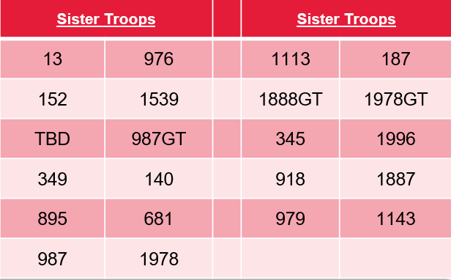

- Other Announcements
- District Chair (mailto:johnkilduff42@gmail.com)
  - District membership goal is close. Please get in any new youth applications.
  - Friends of Scouting (FOS)
    - Hector U has volunteered to be the Family FOS Chair
    - Pat B has volunteered to be the Community FOS Chair
    - Unit kickoff is this Saturday at the Falls Church Presbyterian Church at 8:30am (also on Zoom). Please register so we can know who will attend.
    - Need dates for your Unit’s FOS presentation. Please let me know.
- Awards for Uniformed Leaders – End of the year is a great time to review if your leaders are eligible for awards. Some of them will be leaving as their youth ages out.
- FAQs – Commissioners get many questions from the units. Some of the common questions are now listed in the FAQ section of the George Mason web site.
- Arrow of Light Hike – T1539 is hosting a hike this Saturday (12/11) from Riverbend to Great Falls. This will also meet the Scout Adventure Requirement #2. Contact us at info@Troop1539.us

- District Executive Minute /Jose Calil (via text)
  - Happy Holidays – Happy holidays to our friends and family and I look forward to a strong and exciting new year for our district.

- District Chair /John K
- Thanks – Thank you for all you do. It doesn’t go unnoticed!

- District Commissioner Minute /Hector U
- Peace Light –This is usually done by the International Committee - but they couldn’t this year. Ricardo and T187 thank you for hosting the Peace Light. This has a great Scout tradition with scouts from Austria and the Austrian airlines being sponsors.
- Happy Holidays – Enjoy the holidays and take some time off!

- Minutes and Slides – Will be available on the GMD Web Site (District Resources, Roundtable).

- Next meeting – January 13, 2021, at 7:30pm at Thoreau MS

