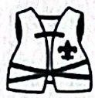

**BOY SCOUTS OF AMERICA**

**NATIONAL CAPITAL AREA COUNCIL**

**Pre-Camp Swim Classification Tests**

**Safe Swim Defense (SSD) and Safety Afloat (SA)**

[**https://ncacbsa.org/Aquatics-Committee**](https://ncacbsa.org/Aquatics-Committee)

**2024 Aquatics Programs**

What: This is an opportunity for your unit to have your annual BSA Swim Classification Check done under supervision of NCAC-approved aquatics personnel.

Who: Any NCAC unit (Pack, Troop, and Crew)

Where: Camp Snyder, Haymarket, VA

When: [June 9](https://scoutingevent.com/082-82691) – One-hour blocks starting at 9am. Last session is 4pm.

Cost: $3 per participant.

What: BSA Safe Swim Defense (26 min) and Safety Afloat (30 min) training is required for any BSA unit conduction swimming or boating activities.

Who: Adult leaders supervising a swimming/boating activity must have completed Safe Swim Defense/Safety Afloat within the previous two years.

Where: SSD and SA training is available online at <https://my.scouting.org>. Any in-person training must be presented by a qualified instructor.

Cost: Free!

What: This the hands-on training that is recommended in Safety Afloat guidelines for anyone conducting Scout boating activities. Two versions of the course are offered: The Basic course covers flat water introductory boating skills and basic trip planning. The river course includes skills and knowledge development that are required for conducting trips on moving water. The Basic course is a prerequisite for the moving water course.

Who: Adult leaders

When:

* Session 1*: [May 18 (Still Water), May 19 (Moving Water)](https://scoutingevent.com/082-82687)
* Session 2**: [June 1 (Still Water), June 2 (Moving Water)](https://scoutingevent.com/082-82688)
* Session 3**: [Aug 24 (Still Water), Aug 25 (Moving Water)](https://scoutingevent.com/082-82689)
* Session 4**: [Sep 7 (Still Water), Sep 8 (Moving Water)](https://scoutingevent.com/082-82690)

Where: * Still Water–Zoom/Silver Lake; Moving Water–Keedysville, MD

** Still Water–Camp Snyder; Moving Water-Riley’s Lock

Cost: $30/class day

**Aquatics Awards**

What: Complete Partial MBs - Lifesaving & Swimming

Who: Scouts BSA (11-17 years), Venture (14-21 years)

Where: TBD

When: TBD – Likely the first weekend in Oct

Cost: $10

**BSA Aquatics Awards**

**Aquatics MB Completion Day**

What: Social Gathering Among Divers

Who: Scouts BSA (11-17 years), Venture (14-21 years)

Where: Lake Phoenix Scuba Park, Rawlings, VA

When: Labor Day Weekend (Aug 30-Sept 2)

Cost: Check Web Site (Scholarships Available)

Note: This is a private organization event and not sponsored by BSA. Registration and waivers must be in by August 15th. https://www.facebook.com/StubaJamVirginia

**ScubaJam Virginia**

**Paddle Craft Safety Training**

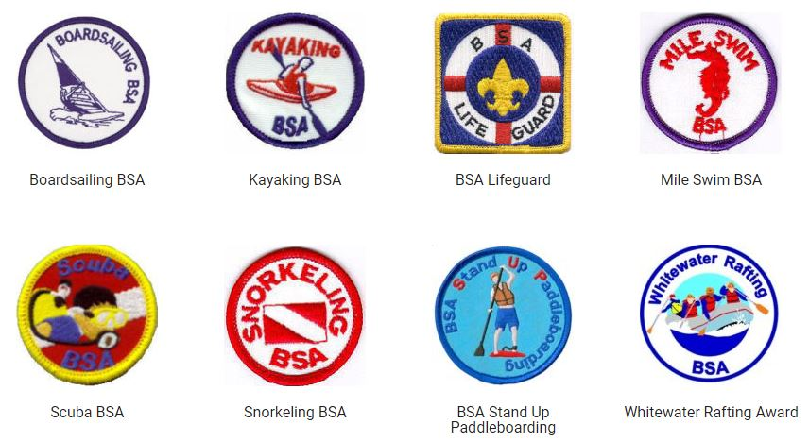

Find the requirements at:

<https://www.scouting.org/outdoor-programs/aquatics/>

These awards are available for any Scouts BSA-aged youth or adult. To work on any of these awards outside of Summer Camp, contact:

Charles Hochstein ([charles.hochstein@usps.gov](mailto:charles.hochstein@usps.gov))

What: BSA Lifeguard Training is professional level training that meets the requirements of government agencies for professional lifeguards at regulated swimming activities. Lifeguard certification qualifies one for many summer opportunities. This class is being conducted by Campaign Pay It Forward (<https://campaignpayitforward.com/booking>, select BSA Lifeguarding from the pull-down menu)

Who: The program is open to all registered adults and older youth (minimum age 15). Strong swimming skills are required. The course includes online pre-work that must be completed before the first session.

Where: Varies

When: Check Schedule

Cost: Check Schedule

**Lifeguard Training**